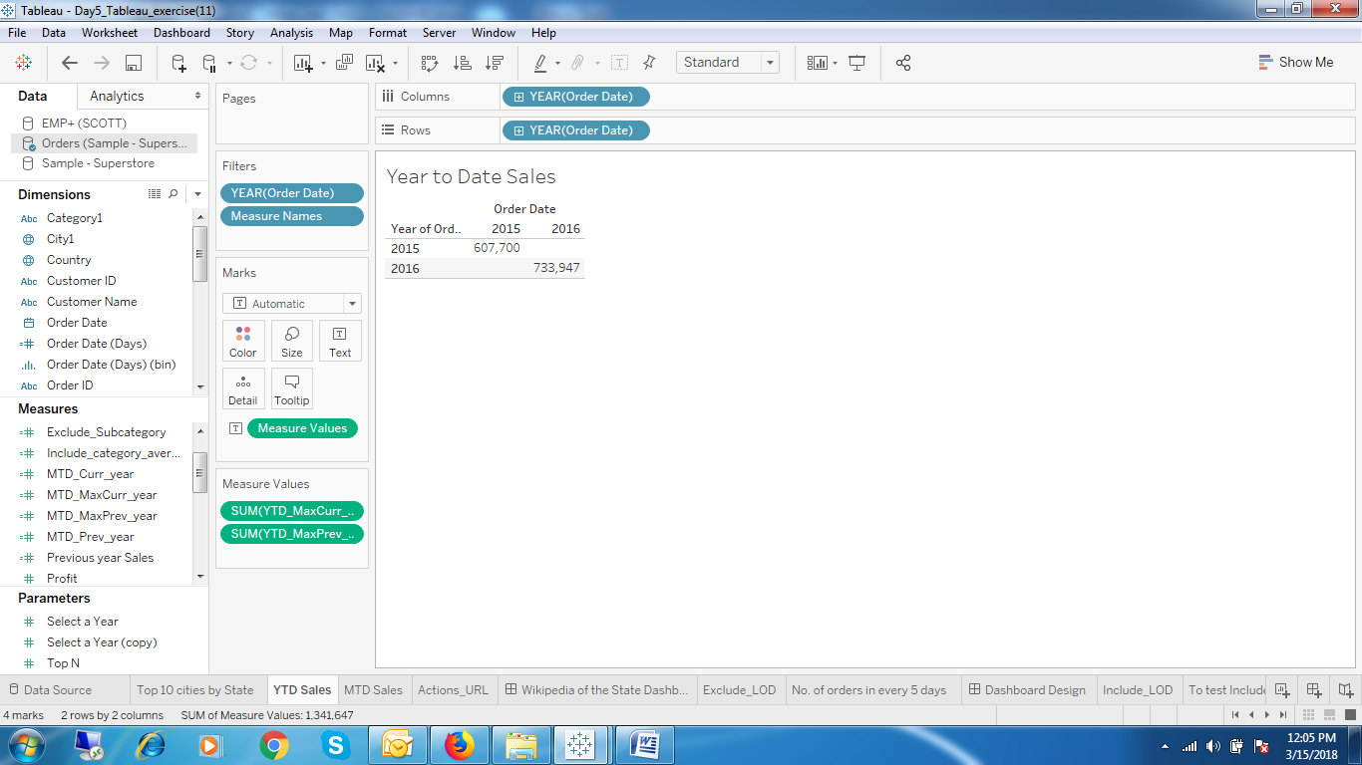

1. If Todays date is March 15 2018, The overall sales from 1-Jan-18 to 15-Mar-18 i.e Current year Sales and 1-Jan-17 to 15-Jan-17 i.e Previous year Sales.

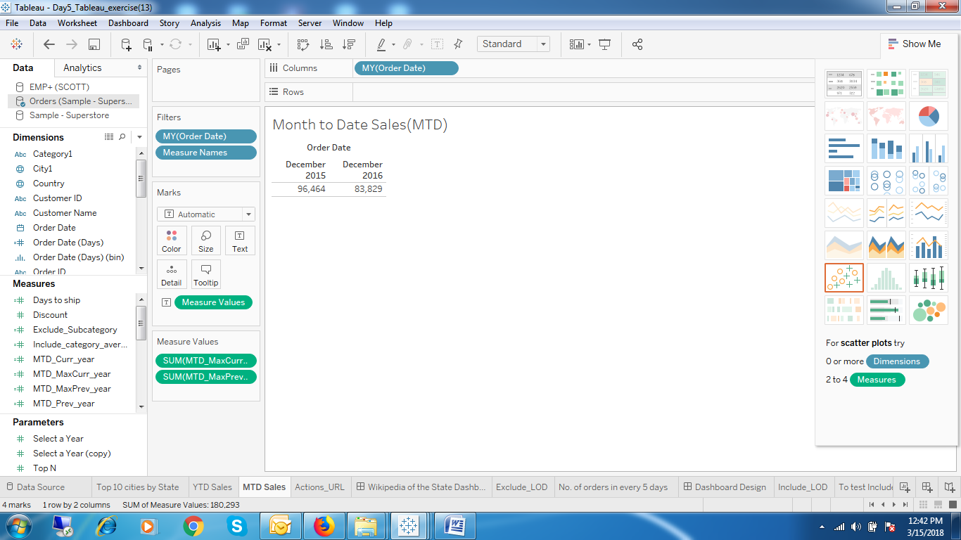

1. If Todays date is March 15 2018, The overall sales from 1-Mar-18 to 15-Mar-18 i.e Current month Sales and 1-Mar-17 to 15-Mar-17 i.e Previous year, same month Sales.

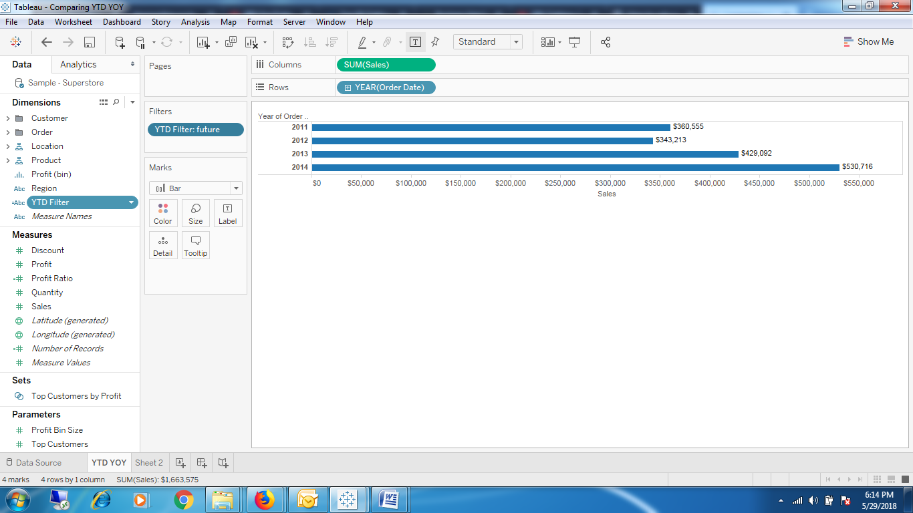

1. YTD sales of all 4 years by applying it in the filter
2. ZN(SUM([Sales])) - LOOKUP(ZN(SUM([Sales])), -1) Month over month

Year

Month

Month

Compute the percent difference of sales by year and month compared to previous

1. ZN(SUM([Sales])) - LOOKUP(ZN(SUM([Sales])), -1) Year over Year

Month

Year

Year

Compute the percent difference of sales by month and year compared to previous

1. (ZN(SUM([Sales])) - LOOKUP(ZN(SUM([Sales])), -1)) / ABS(LOOKUP(ZN(SUM([Sales])), -1))

Year over Year growth

1. RUNNING_SUM(SUM([Sales])) YTD total
2. SUM([Sales]) / TOTAL(SUM([Sales])) Percent of Total